
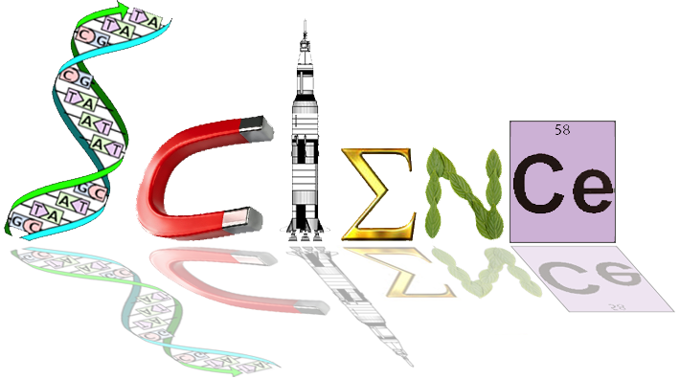

12 HB Human Biology
ATHBY Unit 4 2021

Name: _____________________________________________ Date: ____________________

Task 11 – Mechanism & Evidence of Evolution Test /61 marks

Part 1: Multiple Choice (15 marks)

Question 1 refers to the following diagram of a phylogenetic tree
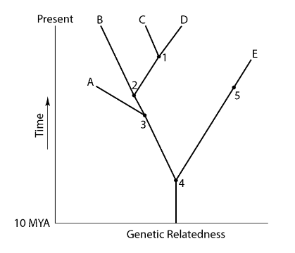

1. A common ancestor for both species C and E could be at position number

- 1
- 2
- 3
- 4

2. Fossilisation of soft tissues is least likely to occur in

- the presence of decay bacteria
- sheltered conditions in a cave
- volcanic ash when organisms are smothered
- swamps under fine mud sediments

3. Homologous organs

- suggest that the species do not share a common ancestor
- are a pair of chromosomes that contain genes that encode for the same structures
- are organs that have a similar structure but may have different functions
- are organs that have a similar structure and similar functions

4. This question refers to the list of statements below.

(i) The fossil record has some specimens that show a gradual progression over an extended period of time to the present day.
(ii) The fossil record shows that some species have undergone no changes over time.
(iii) Protein analysis demonstrates that related species show much similarity in the sequence of their amino acids.
(iv) Vertebrates display a similar arrangement of their upper limb bones.

Which of the above statements provide evidence to support the theory of evolution?

- (i) and (ii) only
- (i), (iii), and (iv)
- (i) and (iv) only
- (i), (ii), (iii) and (iv)

Question 5 refers to the diagram below, which shows the sequences of rock strata from four locations.
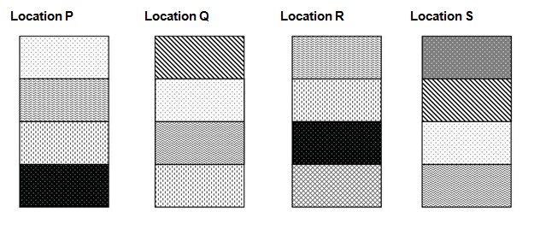
5. Which location appears to have the oldest stratum?

- P
- Q
- R
- S

6. All primates have

- grasping hands, forward facing eyes and five digits
- scent glands, stereoscopic vision and an enlarged cerebellum
- ischial callosities, colour vision and a non-specialised body
- tails, a reduced sense of smell and an enlarged cerebrum

7. Australopithecine fossils have been found in

- Africa
- Africa and Asia
- Africa and Southern Europe
- Africa, Southern Europe and Asia

8. Which of the following correctly lists the cultural advances of the hominin group in the most likely sequence of development (from earliest to most recent)?

- painting, use of fire, manufacture of simple stone tools, agriculture
- agriculture, painting, use of fire, manufacture of simple stone tools
- manufacture of simple stone tools, use of fire, painting, agriculture
- use of fire, painting, agriculture, manufacture of simple stone tools

9. Which of the following is NOT an adaptation to upright stance or bipedal locomotion?

- the foramen magnum is located towards the back of the skull
- the heel bone is enlarged
- vertebrae in the lower part of the spine are wedge-shaped
- the pelvis is broad and short

10. Which of the following statements are true for Homo neanderthalensis?

(i) first hominins known to make use of fire
(ii) first hominins known to construct shelters
(iii) were efficient hunters of large animals
(iv) used flake tools to make clothes
(v) manufactured portable art depicting fertility symbols

Which of the above statements are correct?

- (i) and (iii) only
- (i), (ii) and (iv) only
- (iii), (iv) and (v) only
- (iii) and (iv) only

11. The term ‘carrying angle’ refers to the

- forward tilt of the body of most primates during bipedal or quadrupedal locomotion.
- angle created between the long axis of the femur and the vertical.
- orientation of the foramen magnum to the vertical axis of the skull of most primates.
- forward tilt of the pelvis during bipedal locomotion.

Questions 12 and 13 refer to the lower jaw diagrams shown below.

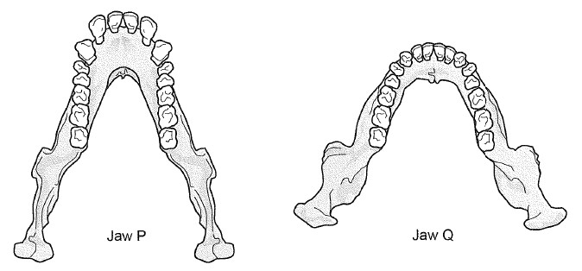

12. Which of the following statements about the lower jaws shown in the diagrams is correct?

- Jaw P belongs to a modern human because the dental arcade has a parabolic shape.
- Jaw Q belongs to a great ape because the teeth are of an even size.
- Jaw P belongs to a great ape because of the presence of a diastema.
- Jaw Q belongs to a modern human because there are more molars present than in Jaw P.

13. If the complete skeleton of the specimen belonging to Jaw Q was examined, which of the following characteristics would it be expected to have?

- longitudinal and transverse arches of the foot
- small outer condyle of the femur at the knee joint
- only one curvature of the vertebral column
- bowl shaped pelvis that is long from top to bottom

Questions 14 and 15 refer to the stone tools shown below.

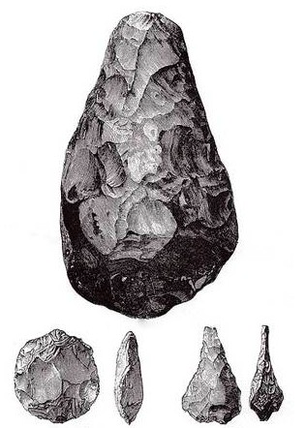

14. To which tool culture do the tools shown above belong?

- Oldowan pebble tools
- Acheulian hand axes
- Aurignacian blade tools
- Magdalenian barbed spears

15. What cultural advance would also be associated with the group of individuals responsible for making the stone tools shown above?

- construction of murals and portable art
- beginning of farming practices
- evidence of rituals and burial of the dead
- beginning to use fire


YEAR 12 ATAR HUMAN BIOLOGY

Task 11: Mechanism & Evidence of
Evolution Test – 8%

NAME:_____________________________

TEACHER:__________________________

DATE:______________________________

Multiple choice section

Answer all questions by placing an X over the most correct answer on the multiple choice answer sheet.

1. a b c d 11. a b c d
2. a b c d 12. a b c d
3. a b c d 13. a b c d
4. a b c d 14. a b c d
5. a b c d 15. a b c d
6. a b c d
7. a b c d
8. a b c d
9. a b c d
10. a b c d
SCORES:
MC: /15

SA: /36

EA: /10

TOTAL: /61

_______ %

Part 2: Short Answer (36 marks)

16. Explain how the study of comparative DNA can provide evidence for evolution. (2 marks)
____________________________________________________________________________________________________________________________________________________________________________________________________________________________________________________________________________________________________________________________________________________

17. Use the table below to answer parts (a), (b) and (c).

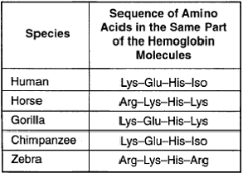

a) The specific type of study shown above is used to provide evidence for evolution. Name this type of study and describe how it provides evidence for evolution. (2 marks)

____________________________________________________________________________________________________________________________________________________________________________________________________________________________________________________________________________________________________________________________________________________

b) Explain how the study of proteins can provide evidence for evolution. (2 marks)

_________________________________________________________________________________________________________________________________________________________________________________________________________________________________________________________________________________________________________________________________________________________________________________________________________________________________________

c) Using the diagram above, explain the evolutionary relationship of the human to the horse compared with the human to the chimpanzee. (2 marks)

_________________________________________________________________________________________________________________________________________________________________________________________________________________________________________________________________________________________________________________________________________________________________________________________________________________________________________
18. Complete the table below, describing the evolutionary trends that occur within the family Hominidae. (3 marks)

Characteristic | Evolutionary trend
Mobility of digits of the hand
Prognathism
Size of molar teeth

19. As hominins evolved their cranial capacity gradually increased. For each of the three functional areas of the cerebral cortex listed below, explain one advantage an increased brain size gave to early Homo sapiens to enable them to survive in their environment. (3 marks)

Functional area of cerebral cortex | Advantage
Association
Motor
Sensory

20. Parts (a) and (b) of the question refer to the hominin skull diagrams A, B, C, and D shown below.

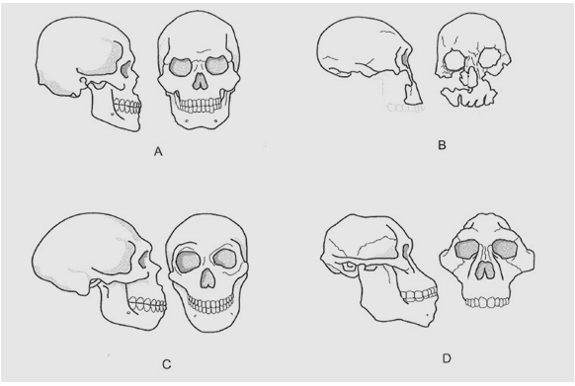

a) Place the skulls A, B, C and D in the correct evolutionary sequence, from oldest to most recent.
(4 marks)

__________________________________________________________________________________________________________________________________________________________________________

b) Describe the evolutionary trend that can be seen in hominin fossils associated with the jaw. Explain why this trend is believed to have occurred. (2 marks)

____________________________________________________________________________________________________________________________________________________________________________________________________________________________________________________________________________________________________________________________________________________

c) Describe the general trend in the evolution of hominin teeth and describe cultural factors that may have influenced this trend. (3 marks)

____________________________________________________________________________________________________________________________________________________________________________________________________________________________________________________________________________________________________________________________________________________

d) What features of a fossilised skeleton would clearly indicate the individual was bipedal? (3 marks)
____________________________________________________________________________________________________________________________________________________________________________________________________________________________________________________________________________________________________________________________________________________

21. (a) Name the hominin that was the first to; (3 marks)

  - use fire ______________________________________________
  - use ritual burial ________________________________________
  - domesticate animals ____________________________________

b) Name the hominin that produced the art forms shown in this diagram. (1 mark)

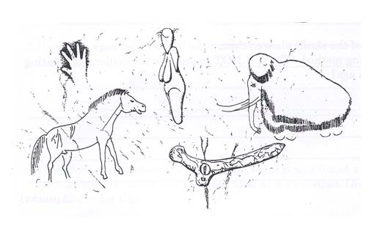

__________________________________________________________________________________________________________________________________________________________________________

c) For each of the following (C1 to C4) identify the tool culture and the associated hominin group.
(4 marks)

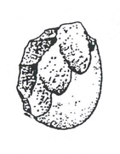
C2
C1
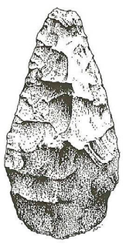

Tool culture____________________________ Tool culture________________________
Hominin______________________________ Hominin__________________________

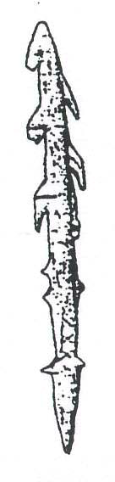
C4
C3
C3
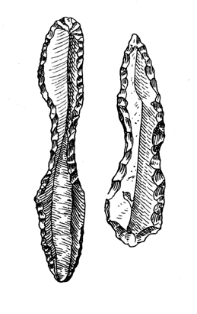

Tool culture____________________________ Tool culture________________________
Hominin______________________________ Hominin__________________________

22. The diagram below shows a phylogenetic tree of present-day hominids. The numbers in ovals at the branch points indicate the percent DNA similarity with humans.

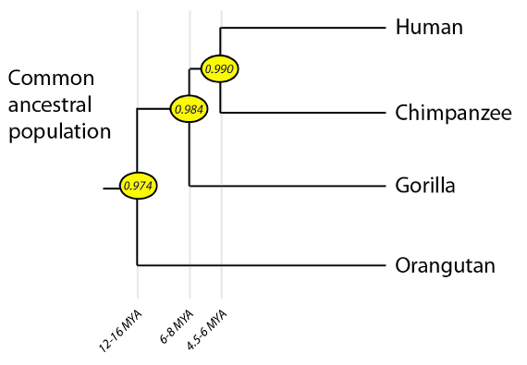

On the basis of the information contained in the phylogenetic tree, are Humans more closely related to Gorillas or Orangutans? Explain your answer. (2 marks)

___________________________________________________________________________________________________________________________________________________________________________________________________________________________________________________________________________________________________________________________________________________________________________________________________________________________________________________________________________________________________________________________________________________________________________________________________________________

Extended Answer (10 Marks)

Archaeologists discovered an almost complete hominid specimen in Israel. The fossil was dated at approximately 60000 years old. Initially archaeologists did not know whether the specimen belonged to Homo neanderthalensis or modern Homo sapiens. With more detailed inspection of the skeletal characteristics it was decided the specimen was Homo neanderthalensis.

a) Describe the steps involved in the evolutionary process that leads to the development of Homo neanderthalensis. (7 marks)
___________________________________________________________________________________________________________________________________________________________________________________________________________________________________________________________________________________________________________________________________________________________________________________________________________________________________________________________________________________________________________________________________________________________________________________________________________________________________________________________________________________________________________________________________________________________________________________________________________________________________________________________________________________________________________________________________________________________________________________________________________________________________________________________________________________________________________________________________________________________________________________________________________________________________________________________________________________________________________________________

b) Describe three features of the post-cranial skeleton (parts of the body that lie posterior to the head) that allowed them to distinguish it as Homo neanderthalensis rather than Homo sapiens. (3 marks)

______________________________________________________________________________________________________________________________________________________________________________________________________________________________________________________________________________________________________________________________________________________________________________________________________________________________________________________________________________________________________________________________________________________________________________________________________________________________________________________________________________________________________________________________________________________________________________________________________________________________________________________________________________________________________________________________________________________________________________________________________________________________________________________________________________________________________________________________________________________________________________________________________________________________________

